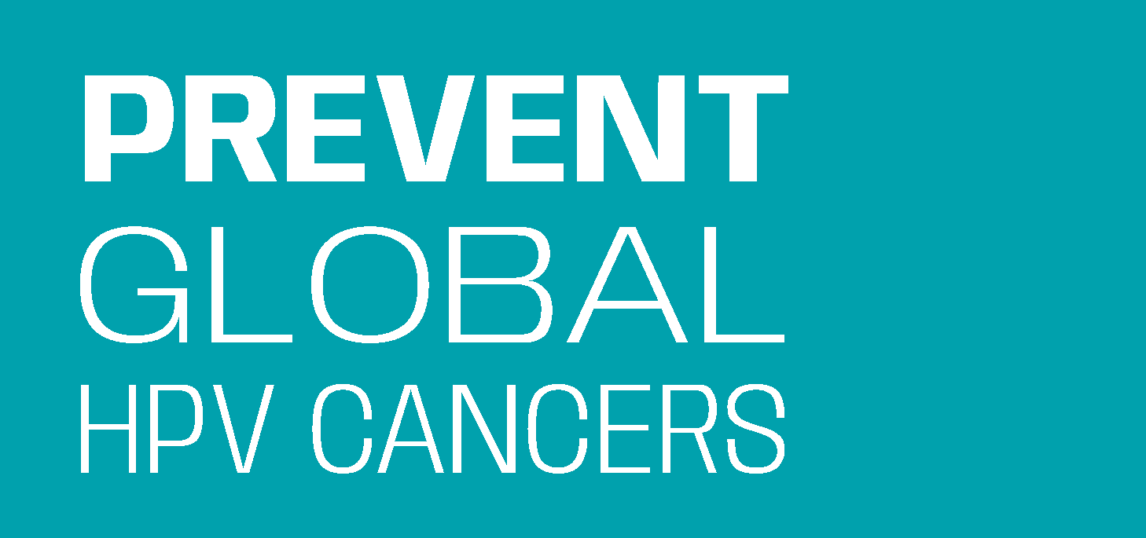
Increasing Uptake of

HPV Vaccine in Kenya:
An Action Plan Template for Civil Society Organisations

Healthcare Facility:
Civil Society Organisation (CSO):
Health Facility Lead:
Civil Society Organisation Lead:
Planning Team Members:
Total number of health facilities participating in the vaccination project:
Resources (human and financial) to support the project:

Overview
The action plan template is designed to serve as a worksheet and facilitation tool for the project team. The document is divided into three parts:
- Pre-project assessment - A set of questions to help you review current HPV vaccination practices and data at the health facility. These questions should be answered or validated by the health facility leadership before starting the action plan.
- Action plan - A tool to help you plan and track your activities to be used in coordination with the Action Guide. Select activities that are a best fit for your organisation and resources.
- Post-project assessment - A set of questions to help reflect on the results, successes, and challenges of the project.

Pre-Project Assessment:
Resources

- Resources (human and financial) available to support the HPV vaccination work over the next __ months:
Notes:

Eligibility

- Free HPV vaccinations currently being given to 10 to 14-year-old girls: Yes/Not yet
Notes:
Facility Staff/Volunteer Readiness to Mobilise Community and Answer Parent Questions
- Educational posters and pamphlets for parents on HPV vaccination for cervical cancer prevention are available in the waiting area or other places: Yes/Not yet
- Facility staff are knowledgeable of HPV vaccination and ready to answer parent questions about cervical cancer and the vaccine in-clinic. Ready Somewhat Ready Not ready
- Health care workers are knowledgeable of HPV vaccination and ready to answer parent questions about cervical cancer and the vaccine during community outreach. Ready Somewhat Ready Not ready
- Training that in-clinic staff and community health workers (CHVs/CHAs/CHEWs) have received on HPV vaccination and cervical cancer prevention:
  - Curriculum/manuals/resources used for the training:
  - Facility is open to additional HPV vaccination training using the materials provided in this guide: Yes/Not yet
Notes:

HPV Vaccination Data

- Does health care facility track HPV vaccination data? Yes/Not yet
- If yes, how many girls aged 10 - 14 years received a dose of the HPV vaccine last year from this facility?
- Does facility have a goal for how many girls aged 10 - 14 will receive a dose of the HPV vaccine in the current/next year at this facility? Yes/Not yet
If yes, what is the goal?
Notes:

Project Goals
- Desired result for HPV vaccination at the Health care Facility:

Notes:

After completing the pre-project questions, CSOs should have the following in place:
- Established relationship with health facility staff and leadership
- Current data on HPV vaccination at the facility
- Understanding of the facility layout, staffing, and how parents/guardians navigate the facility with their 10 to 14-year-old daughters for HPV vaccination.
- Established a goal for HPV vaccination of ____ number of girls to be achieved in ____ months

Action Plan:
The action plan is a place to keep track of project planning notes and progress. The action plan should be used in connection with the Action Guide and supporting resources. As you start planning, consider activities that are appropriate for the facility based on what you have learned during the pre-project assessment. Feel free to add activities that are not suggested in the Action Guide but are relevant in your situation.

Action 1
Strengthen Capacity of Community Health Volunteers and Community Health Assistants
Progress Markers: Use this space to track progress of activities selected below.
Examples: # of healthcare workers trained, # CHVs trained, # CHEWs trained

Activities (who, will do what, by when?) | Name(s) of individual responsible | Deadline | Status (NA, or update)
Support health facilities with their continuing education and training needs and priorities.
- Assess, with the facility-in-charge, specific education and training needs to support the HPV vaccination project goal.
- Collaborate on holding 1-2 day continuing education and training sessions, as needed, and include the following:
  - Highlight the burden of cervical cancer in Kenya, the safety and effectiveness of HPV vaccination, and its cancer prevention benefits. (contact us for Presentation: HPV Vaccination Training for Health Workers)
  - Give tips on how to effectively recommend HPV vaccine to parents/guardians and how to respond to their questions. (see training presentation and handouts)
  - Help CHVs/CHAs practice making a recommendation to parents/guardians and using effective responses to parent questions.
  - Consider providing a training completion badge, button, or apron that says “Community Health Champion: Ask me about the HPV vaccine” and can be worn during home visits. (designs available)
Provide job aid and parent-focused resources to CHVs/CHAs.
- Distribute materials for future reference including the HPV Fact Sheet: Frequently Asked Questions, and more. (see resources)
- Provide HPV vaccination education materials to give to parents/guardians. (see Don’t Wait to Vaccinate)
- Share other relevant community resources, if available, to encourage and support parents to get their eligible daughters to the clinic for vaccination (Example: transportation or financial support)
- Print and distribute information, education and communication (IEC) materials.
- Other
Resources for Action 1: Factsheet for Healthcare Workers: Frequently Asked Questions, HPV Vaccination Job Aid for CHVs, HPV Vaccination Educator Wearable design(s), Don’t Wait to Vaccinate handout, HPV Vaccination poster, Contact us for access to Presentation: HPV Vaccination for Health Workers
Action 2
Leverage all opportunities to recommend and remind parents/guardians to get their daughters vaccinated before their 15th birthday.
Progress Markers: Use this space to track progress of activities selected below. Example: # of girls aged 10-14 vaccinated with the HPV vaccine during the project period.

Activities (who, will do what, by when?) | Name(s) of individual responsible | Deadline | Status (NA, or update)
Partner with health facilities to prompt parents and guardians to ask about HPV vaccination at the facility.
- Engage health facility staff to identify high-visibility, high-traffic areas in the facility.
- Support the display of posters and flyers in high-visibility areas to serve as a reminder to parents/guardians and staff about the HPV vaccine and its benefits as cervical cancer prevention. (see resources)
- Find opportunities to share HPV vaccination education materials with parents/guardians. Potential moments include when parents/guardians enter the facility, while parents/guardians are in waiting areas, and at the vaccination nurse’s station.
Recommend and remind parents and guardians during home visits about the benefits of HPV vaccination.
- Motivate CHVs and CHAs to recommend HPV vaccination at every meeting with parents/guardians of age-eligible girls:
- Emphasise that the HPV vaccine is for cervical cancer prevention; it is free; and it is a part of the government’s routine immunisation schedule.
- Answer parents’/guardians’ questions about the HPV vaccine with facts. (see Factsheet for Healthcare Workers: Frequently Asked Questions)
- Leave parents/guardians with resources. (see Don’t Wait to Vaccinate handout)
- Encourage CHVs and CHAs to discuss with parents/guardians the best opportunity to visit the clinic with their daughter (clinic hours, days, location).
- Remind CHVs and CHAs to conduct follow-up visits or call families to make sure that HPV vaccination is complete.
- Other
Resources for Action 2: In-Facility poster, Don’t Wait to Vaccinate handout.

Action 3
Track Progress & Share Lessons Learned
Progress Markers: Use this space to track progress of activities selected below.
Examples: # of champions recognized

Activities (who, will do what, by when?)  Use the checkboxes below to select only the activities that are a best fit for your organisation and resources or develop your own actions. | Name(s) of individual responsible | Deadline | Status
- Support CHVs and CHAs in tracking and reporting back to county health facilities on the efforts within communities.
- Help identify CHV/CHA peer leaders who have prioritised HPV vaccination in their work and can provide on-going support and motivation to other CHVs/CHAs who need assistance.
- Support the recognition of champions at the facility level and in the community. Consider providing certificates of recognition through the county health facility leadership. (see Sample Certificate of Recognition)

- Explore opportunities for high-performing county health facility leaders to share project success, best practices and lessons learned with other county health facilities.
- Other
Resources for Action 3: Sample Certificate of Recognition

Post Project Assessment:
These questions will help reflect on the impact of your project supporting the health facility to increase the uptake of HPV vaccination in communities.

Staff & Volunteer Preparedness
____Number of HPV Vaccination for Cervical Cancer Prevention Trainings
____Number of health care facility staff trained
____Number of CHVs trained
____Number of CHEWs trained
____Number of HPV Vaccination Champions recognized and/or celebrated

Overall Project
- Key successes of the project:

- Major challenges to the project:

- Overall project goal:

- Desired result for HPV vaccination at the Healthcare Facility met: Yes/No

- CSO will continue to work towards improving HPV vaccination coverage: Yes/No
If yes, please provide brief description:
- Health facility will continue to work on improving HPV vaccination coverage: Yes/No
If yes, please provide brief description:

The Prevent Global HPV Cancers Team would love to hear about your project. Please reach out to share your experience with the project by emailing: GlobalCancerPrevention@cancer.org.

preventglobalhpvcancers.org

Prevent Global HPV Cancers is a collaborative initiative supported by the American Cancer Society’s Global HPV Cancer Free program.
Last revision March 2023.

