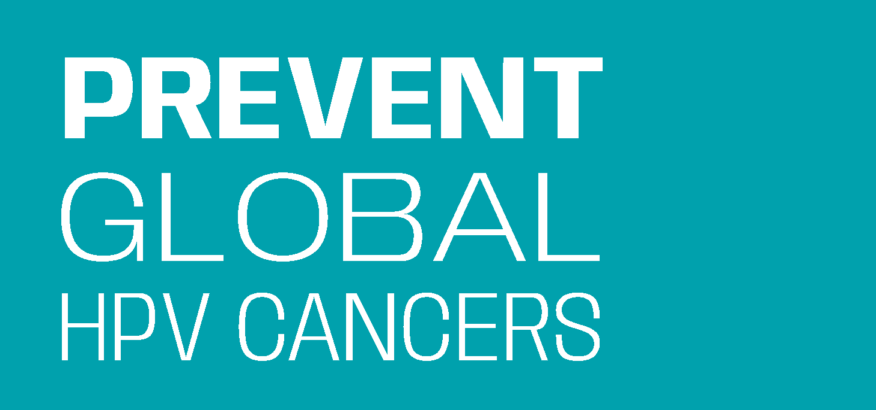
Cervical Cancer Prevention
Through HPV Vaccination:

An Action Plan Template for Medical Societies in India

Medical Society:
Medical Society Lead:
Partner Lead, if applicable:
Planning Team Members:
Resources (human and financial) to support the project:

Overview
The action plan template is designed to serve as a worksheet and facilitation tool for the project team. The document is divided into three parts:
- Pre-project assessment - A set of questions to help review current HPV vaccination practices and data of the medical society. These questions should be answered or validated by the medical society leadership before starting the action plan.
- Action plan - A tool to help plan and track activities to be used in coordination with the Action Guide. Select activities that are a best fit for the organisation and resources.
- Post-project assessment - A set of questions to help reflect on the results, successes, and challenges of the project.

Pre-Project Assessment:
Resources

- Resources (human and financial) available to support the HPV vaccination work over the next __ months:
Notes:

Process and Policy

- How do HPV and cervical cancer elimination align with the medical society’s long-term vision?

- What is the society's official position statement on cervical cancer prevention or HPV vaccination?

- Is HPV vaccination included in the society’s published clinical guidelines for recommended vaccinations, adolescent health, cancer prevention, etc?

- What opportunities are there to integrate HPV vaccination into existing medical society prioritisations or efforts?
Notes:

Leadership and Member Training
- What type of training has the leadership and/or members received about HPV vaccination and cervical cancer prevention?
Notes:

Project Goals
- What are the desired results of this project? If the project goals include HPV vaccination uptake change, list the specific rate of change desired.
Notes:

After completing the pre-project questions the Planning Team should have the following in place:
- Established project planning team
- Developed a project goal
- Assessment of internal resources for the project

Action Plan:
The action plan is a tool to assist the Planning Team with discussing and deciding on project activities and their implementation. The action plan should be used in connection with the Action Guide and supporting resources. When planning, consider activities that are appropriate for the medical society based on what was learned during the pre-project assessment. Feel free to add activities that are not suggested in the Action Guide but are relevant to the medical society.

Action 1
Alert member physicians of high risk of cervical cancer and their pivotal role in preventing it.

Progress Markers: Use this space to track progress of activities selected below.
Examples: # of physicians attending HPV vaccination trainings, # of physicians receiving facts about cervical cancer and HPV vaccination through webinars, quarterly newsletter, President’s letter, etc.

Activities (who, will do what, by when?)  Review all activities. Keep activities that are a best fit for the project. Modify proposed activities or develop your own activities. Delete activities that are not in the project scope. | Name(s) of individual responsible | Deadline | Status (NA, or update)
Example: Send a letter from the President to members alerting them of high rates of cervical cancer and impact of HPV vaccination | Communications chair | January 10th | Letter drafted, to be sent on December 1st
- Publish a letter to members from medical society leadership describing the magnitude of the cervical cancer problem and urge them to follow recommended HPV vaccination guidelines with all 9 to 14-year-old girls in their practice.
- Share key cervical cancer and HPV vaccination facts, statistics, and messages with members by distributing information, education, and communication (IEC) materials, such as in-clinic poster, don’t wait to vaccinate parent flyer, HPV facts, etc.
- Remind physicians of the incidence and seriousness of cervical cancer and the impact of strong physician recommendations on HPV vaccine uptake by parents. Use the medical society’s regular communication channels. Examples include newsletters, websites, emails, social media platforms, conferences, podcasts, and webinars.
- Include oncologists as speakers in education opportunities including HPV training, medical conferences webinars, and continuing medical education courses.
- Use cervical cancer awareness events to promote the facts about cervical cancer and the life-saving benefits of HPV vaccination. Examples include Cervical Cancer Awareness Month (January), World Cancer Day (Feb 4), International HPV Day, (March 4) International Women’s Day (March 8).
- Promote the use of the in-clinic poster (see resources) that can serve as a conversation starter with parents.
- Collaborate with other national medical societies and cancer centres on HPV vaccine activities to show broad support and increase impact.
Other
Resources: Key Messages for Physicians, Sample Letter to Members, Factsheet for Physicians on HPV Vaccination, Dosing Guide & FAQ for Physicians, Counselling Parents on HPV Vaccination flyer, Don’t Wait to Vaccinate parent handout, In-Clinic Poster, Physician Champion Video

Action 2
Cultivate HPV vaccination physician champions.
Progress Markers: Use this space to track progress of the activities selected below. Example: # of champions trained, # of champions recruited, # of champions trained, # of physicians reached through champion outreach

Activities (who, will do what, by when?)  Review all activities. Keep activities that are a best fit for the project. Modify proposed or develop your own activities. Delete activities that are not in project scope. | Name(s) of individual responsible | Deadline | Status
Example: Identify 5-10 potential physician champions and contact them to assess their interest. | Core Committee | November 1st | Physicians contacted, 2 said yes, 3 said no, waiting on a response from 5
- Identify physicians who are widely known and well-respected, having personal interest and commitment to cervical cancer prevention, fluency in local language(s), and good communication skills.
- Recruit identified physicians to champion the HPV vaccine at national, state, and district levels.
- Share and reinforce use of Key Messages for Physicians when communicating about HPV vaccine with champions.
- Involve champions in medical society events such as cervical cancer awareness events, educational webinars, conferences, newsletter articles, etc.
- Provide champions with ready-to-use messages and materials that they can share with other physicians at regular intervals during the project.
- Help champions with HPV vaccination education and outreach using medical society or partner communication platforms. Communication platforms may include social media, podcasts, blog posts, email blasts, op-eds, and newsletter articles.
- Check-in with champions to track their efforts and provide additional support as needed
- Report back to champions on the impact of their efforts. For example: share the number of views of their video received or number of participants who attended a webinar.
- Recognize the work of champions. For example, highlight them with photos and quotes on why they think advocating for the HPV vaccine is important. Acknowledge their contributions and efforts during association member meetings and webinars.
Other
Resources: Key Messages for Physicians, Letter to Physician Champions, Factsheet for Physicians on HPV Vaccination, Dosing Guide & FAQ for Physicians, Counselling Parents about the HPV Vaccine flyer, Physician Champion Video. Contact us for presentations: Presentation for Physicians: HPV Vaccination Overview, Presentation for Physicians: How to Counsel Parents on HPV Vaccination

Action 3
Recognise and share successes in increasing HPV vaccination.
Progress Markers: Use this space to track progress of the activities selected below. Example: # of champions recognized.

Activities (who, will do what, by when?)  Review all activities. Keep activities that are a best fit for the project. Modify proposed or develop your own activities. Delete activities that are not in project scope. | Name(s) of individual responsible | Deadline | Status
Example: Identify 1 physician or clinic to highlight HPV vaccination successes in the next three newsletter articles. |  | March 1st | Physicians and clinics identified. Stories in draft. Scheduled for June, September, and December newsletters.
- Highlight HPV vaccination successes at regular intervals during the project using multiple communication channels like newsletters, e-mails, conferences, videos.
- Recognise individual physicians and clinics who are changing clinical practice to include HPV vaccination. Simple ways to identify physicians and clinics include peer nominations and member surveys. Provide a certificate of recognition for display in clinics.
- Create an award for extraordinary leadership in HPV vaccination. Present the award at the medical society’s annual conference.
Other
Resources: Sample Certificate of Recognition

Post Project Assessment:
These questions will help reflect on the impact of your project to increase the uptake of HPV vaccination.

Process and Policy

What changes, if any, to HPV vaccination processes or policies have resulted from this project?

Leadership and Member Education and Training
____How many physicians were educated about HPV vaccination and cervical cancer prevention?
____How many HPV vaccination physician champions were recruited and engaged?
____How many HPV vaccination champions were recognised or celebrated?

Overall Project
Key successes of the project:

Major challenges to the project:

Overall Project Goal:

Was the overall project goal met? Yes/No

The Prevent Global HPV Cancers Team would love to hear about your project. Please reach out to share your experience with the project by emailing: GlobalCancerPrevention@cancer.org.

preventglobalhpvcancers.org

Prevent Global HPV Cancers is a collaborative initiative supported by the American Cancer Society’s Global HPV Cancer Free program.
Last revision March 2023.

